INTERNSHIP PACKET
HST 484, PHI 484, REL 484 JST 484: Internship

The School of Historical, Philosophical and Religious Studies encourages students to pursue internships related to their career aspirations. Internships provide practical experiences for students that complement their formal academic class-based studies. Depending on the internship site, internships may be voluntary or paid.

INTERNSHIP PROJECT EXAMPLES

Internships can include but are not limited to:
- Research for company projects
- Assisting in organizing community programs
- Assisting in social media management of company/organization
- Managing specific projects or assist in goals or mission within company/organization

SHPRS is willing to work with internship sites to arrange estimated time required to accommodate the credit hour requirement. We are extremely open to working with our potential sites to foster the best experience possible for all interested parties.

DURING THE INTERNSHIP

- The intent of an internship is for the student to gain career skills through hands-on experiences. Interns should not serve as a greeter, at an information desk, or as an administrative assistant for internship sites.
- Throughout the internship experience, students are required to keep track of their hours each week and submit a summary of hours
- Students area also required to log into their Canvas site weekly for reflections and summaries of their experience.
- At the end of the experience, the student must work with their intern site supervisor to obtain verification of completed hours (start and end dates, along with total hours accrued) and successful completion of duties. There will be a self-evaluation and an evaluation from your supervisor. This must be submitted via email from the supervisor directly. It should be sent to amy.kaiman@asu.edu. All forms will be available on your Canvas page.
- It is the student’s responsibility to get the supervisor report to the School’s Internship Coordinator so that they receive a final grade for HST/PHI/REL/JST 484.
- All documents (logs and supervisor letter) are due by 5pm on the last day of classes for the semester enrolled.

CREDIT HOURS

The number of credit hours received for an internship is based on the total internship hours completed. 45 internship clocked hours = 1 ASU credit hour. For a standard 3-credit internship, 135 internship hours are required. This is approximately 9-10 hours per week in Fall/Spring semesters No more than 6 internship hours per semester may be taken (12 credit lifetime limit).

Hours must be completed and all records must be submitted by the last day of classes, of that term, so grades may be posted in a reasonable time frame.
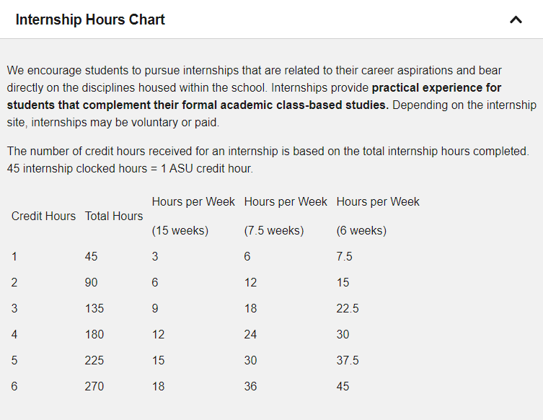

GRADING

At the end of the semester, it is the student’s responsibility to provide the final weekly log and evaluations to the Internship Coordinator. Failure to complete any requirements will result in a Failure (E) for the course. Grades for the course are only pass (Y) or fail (E). No Incomplete grades or letter grades will be allowed. A pass grade (Y) does not get computed into the GPA.
INTERNSHIP PROPOSAL & CONTRACT
HST 484, PHI 484, REL 484: Internship

STUDENT CONTACT INFORMATION
Student Name:
Phone Number:
ASU ID: | Affiliate ID, starts with 1000 or 1200
E-Mail Address:

SITE INFORMATION
Location where the student will be conducting hours, site supervisor and supervisor contact info.
Site Name:
Supervisor:
Phone: |  | Email:

INTERNSHIP DUTIES

HOURS
See attached hours chart to determine credit hours. 3 credits = 9 hours per week (for 15 weeks).
Credit Hours:

STUDENT AGREEMENT AND SIGNATURE
By signing, I affirm that all statements are true and that I will complete the noted internship hours.
Name: (printed)
Signature: |  | Date:

SITE SUPERVISOR AGREEMENT AND SIGNATURE
By signing, I affirm that all statements are true and that I agree to sponsor the student listed for a School of Historical, Philosophical and Religious Studies Internship and agree to provide verification and evaluation of student intern hours.
Name: (printed)
Signature: |  | Date:

OFFICE USE ONLY
DATE SEMESTER |  | LINE #

