

School of Historical, Philosophical & Religious Studies

**HANDBOOK**

#### Updated 1-2021



**Coor Hall**

*The School of Historical, Philosophical & Religious Studies handbook provides information on general operations, business processes, events, research funds, academic/teaching resources and student services.*

*Hyperlinks are embedded in the document, click on the link or press control and click on the text to be directed to the respective webpage.*

*Please contact the SHPRS Front Desk Office Specialist for any updates, questions, or concerns.*

Table of Contents

OUR MISSION 5

SCHOOL INFORMATION 6

Administration 7

Administrative and Academic Staff 8

GENERAL OPERATIONS 12

Bylaws/Policies & Procedures: 12

Computer Assistance 12

Computer Security 12

Copiers/Scanning/Fax 12

Desktop printers 12

Emergencies/Fire Drills 12

Environmental Control/Misc Building Requests 13

Faculty Meetings 13

Faculty Webpages 13

Guest Parking 13

Laptops and Zoom Video Conferencing 14

General Supplies 14

Lounge* 14

Mail* 14

New Employees/Onboarding 15

Mandatory Trainings 15

Office/Building Keys/Keyless Door Access (ISAAC) 15

Office Supplies 16

Payroll Dates 16

Personal Safety and Security 16

Printer Resources 16

Recycling 16

Room Reservations Seminar/Conference Rooms 16

School e-mail Distribution lists 17

Staff and Faculty Parking: 17

Sun Cards 18

Telephone Service Report 18

Trash Pickup 18

Updating Directory Information/Personal Information 18

iSearch 18

Work Orders 18

University Holiday 19

BUSINESS – EVENTS – RESEARCH FUNDING 19

Academic Personnel Actions 19

Annual Faculty Reviews 19

Hosting/Coordinating Faculty Event 19

Institute for Humanities Research 20

Independent Contractors 20

Leaves Management 21

Purchases 21

Recruitment and Hiring 21

Reimbursements 21

Sabbaticals 22

Sick/Vacation time 23

Staff Evaluations: 23

Start-up Funds 23

Travel 23

Travel Without an Overnight Stay 25

Travel Instructions – Zero Dollar Trip 26

COVID-19 Travel Reimbursement Update 26

ACADEMIC/TEACHING RESOURCES - STUDENT SERVICES 26

Academic Integrity: 26

Cancelling Class 27

Class Assignment Drop off 27

Commencement/Convocation Ceremonies 27

Course Evaluations 27

Course Overrides 28

Course Scheduling 28

School Meetings 28

Finals 28

Grade of EN 28

Incompletes 28

Individually Arranged Courses 29

Instructional Design 29

Make-up Exams 29

Office Hours 29

Posting Grades 30

Syllabi 30

Testing Services 30

Textbook/Desk Copy Orders 30

GRADUATE PROGRAMS 31

UNDERGRADUATE ADVISING 31

Appendix 1: Business Meal Reimbursement Form 32

Appendix 2: SHPRS Purchase/Reimbursement Request 33

Appendix 3: Faculty Event Checklist 34

Appendix 4: Desk Copy Request Form 35

Appendix 5: Personal Time with Business Travel 36

# OUR MISSION

Through our teaching, scholarship and community engagement, we seek to mold global citizens with democratic values. Though our core is firmly based in the humanities—the critical, historical and comparative study of texts, practices, and contexts—we sustain strong ties to our colleagues in the natural and social sciences, the professional schools and beyond. From the multiple disciplinary approaches of [**history,**](https://shprs.clas.asu.edu/history)[**philosophy**](https://shprs.clas.asu.edu/philosophy) and [**religious studies**](https://shprs.clas.asu.edu/religious_studies) we investigate those matters that most make us human—mind, rationality and morality, spirit, and memory; our current areas of strength include: history and philosophy of science, intellectual history and history of philosophy, American and global religious history and cultures, environmental history and bioethics, women’s history and feminist philosophy, Native American history and indigenous epistemologies, history and philosophy of politics and the quest for justice; history, philosophy and politics of religion.



# SCHOOL INFORMATION

The School of Historical, Philosophical and Religious Studies (SHPRS) is located in Coor Hall.

Named after Lattie F. Coor, ASU’s fifteenth president, Coor Hall was opened in 2004. The writings on the windows are part of Chicago artist BJ Krivanek public art project. They represent the universal potential of language.

*Named after Lattie F. Coor, ASU’s fifteenth president, Coor Hall was opened in 2004. The writings on the windows are part of Chicago artist BJ Krivanek public art project. They represent the universal potential of language.*

SHPRS occupies space on the third and fourth floor:

Third Floor: Student services (undergraduate/graduate), Philosophy and Religious Studies faculty, Center for Asian Research, Graduate TAs

Fourth Floor: Administrative offices, Student services (graduate), History and Religious Studies faculty, Graduate TAs, and Instructional Design Studio

The mailing address is:

#### School of Historical, Philosophical and Religious Studies Coor Hall, 4th floor

**PO Box 874302**

**Arizona State University Tempe, AZ 85287-4302**

The physical address is:

#### School of Historical, Philosophical and Religious Studies 975 S. Myrtle Avenue

**Tempe, AZ 85281**

Telephone: 480-965-5778

FAX: 480-965-0310

Front desk email: [ShprsFrontDesk@asu.edu](mailto:ShprsFrontDesk@asu.edu)

Website: <https://shprs.clas.asu.edu/>

Advising email: [ShprsAdvising@asu.edu](mailto:ShprsAdvising@asu.edu)

SHPRS Resource Page: <https://shprs.asu.edu/faculty-and-staff-resources>

# Administration

#### Richard Amesbury

Director

**Catherine O’Donnell**

Faculty Head-History

**Cheshire Calhoun**

Faculty Head-Philosophy

**Leah Sarat**

Faculty Head-Religious studies

#### Christopher Jones

Assistant Director, Graduate Studies

#### Katherine Osburn

Assistant Director, Undergraduate Studies

**Laurie Manchester**

Associate Head, Undergraduate Studies

#### Douglas Portmore

Associate Head, Graduate Studies

**Peter Kung**

Associate Head, Undergraduate Studies

**Joel Gereboff**

Associate Head, Graduate Studies

**Jason Bruner**

Associate Head, Undergraduate Studies

#### Gaymon Bennett

Associate Director, Research

**Peter Van Cleave**

Director Online Programs

**Matthew Casey**

Associate Director Online Programs

# Administrative and Academic Staff

**Becky Tsang,** Assistant Director, Academic Operations/Advancement Initiatives (Coor 4488)

* Manage academic logistics to ensure/support school revenue
* Staff supervision
* Oversees SHPRS Budgets and Accounts
* Scholarship/Fellowship/Award Administration
* Space and Technology
* Supports Director

**Academic Affairs**

**Marissa Timmerman,** Manager, Academic Support (Coor 4488)

* All course scheduling processes
* Instructor Course Funding verification
* Undergraduate/Graduate degree programs administration (online and immersion)
* Scheduling and curriculum management
* Course and instructor evaluations
* Supports ADUS, ADGS, AHUS, AHGS

**Academic Advising - Undergraduate**

**Manisha Master**, Manager, Academic Advising (Coor 3316)

* Advising supervision
* Major maps, undergraduate catalog copy, and DARS coding interface
* Advising liaison to CLAS and ASU Online (including success coaches)
* Advises students in all SHPRS majors, minors, and certificates, both on-campus and online
* Advises students on academic probation
* Manages individually arranged courses
* Academic Record Changes
* Roster Contact

**Michael Currey,** Academic Success Coordinator (Coor 3312)

* Advises students in all SHPRS majors, minors, and certificates, both on- campus and online, including students on academic probation
* Supervises third floor student workers, including front desk Office Assistants and the SHPRS Writing Tutor
* Coordinates creation of SHPRS Class Blocks
* Coordinates SHPRS first-time freshman initiatives (including More to Explore event and Humanities Early Start)
* Assists with major maps, undergraduate catalog copy, and DARS coding interface
* Processes overrides
* Authorized approver/signer for the following: enrollment change requests (late adds and backdated drops), concurrent degrees, certificates, and complete session withdrawals

**Amy Kaiman,** Academic Success Specialist (Coor 3384)

* Advises students in all SHPRS majors, minors, and certificates, both on- campus and online, including students on academic probation
* Processes overrides
* Coordinates SHPRS internship program (helps students identify internship opportunities, facilitates enrollment into SHPRS 484 internship courses, and serves as instructor/mentor for the 484 courses)
* Liaison with Career Services in support of career resources for SHRS students
* Plays lead role in completion of prerequisite purge reports

**Carole Gallucci,** Academic Success Specialist (Coor 3309)

* Advises students in all SHPRS majors, minors, and certificates, both on- campus and online, including students on academic probation
* Processes overrides

**Krista Kilian,** Academic Success Specialist (Coor 3305)

* Advises students in all SHPRS majors, minors, and certificates, both on- campus and online, including students on academic probation
* Processes overrides

**Kristin Farnsworth,** Academic Success Specialist (Coor 3313A)

* Advises students in all SHPRS majors, minors, and certificates, both on- campus and online, including students on academic probation
* Processes overrides

**Academic Advising – Graduate Programs**

**Mark Barrios**, Graduate Program Student Services Support Coordinator (Coor 4499A)

* Tracks graduate application process/Processes acceptance/denials for Tempe MA students and PhD students
* Advises graduate students in managing programs of study and funding
* Assists with applications to graduate college for student funding

**Kathy O’Malley**, Academic Success Specialist (Coor 4499C)

* Tracks graduate application process/Processes acceptance/denials for WWII Studies students
* Advises graduate students in managing programs of study
* Initiates probations and dismissals

**Roxanne Shand**, Academic Success Coordinator (Coor 3382)

* Tracks graduate application process/Processes acceptance/denials for online History MA students
* Advises graduate students in managing programs of study
* Initiates probations and dismissals

**Business Office**

**Yvonne Delgado**, Manager, Business Office (Coor 4479)

* Supervises Business Office staff and processes
* Assists in managing accounts and budgets
* HR and Payroll
* Academic Personnel Actions
* Faculty and Staff searches
* Fellowship/Business Leave Representative

**Carrie Montana**, Business Operations Specialist (Coor 4475)

* Manages SHPRS account balances
* Travel Approval
* PCard Manager
* Foundation Accounts (IFAS)

**Rob Cochran**, Business Operations Specialist (Coor 4477)

* Reimbursements/Honorariums/Purchasing
* Student Worker hires
* Medical and FMLA Leave Representative

**Jamise Caesar**, Office Specialist (Coor 4595) Front Desk

* Manages front desk – conference room reservations, facilities requests, copy/scanning requests, office moves, surplus requests, and make up exams.
* Computer and office supply purchasing
* Travel support - Concur
* Keys/ISAAC access, desk copy orders, equipment/computer inventory

**Communications**

**Erica May**, Manager Marketing and Communications (Coor 4474)

* Strategic Communications
* Media relations
* Alumni and donor relations
* Marketing
* Website management
* Newsletters
* Digital and print collateral
* Supervise Communications Coordinator

**Rachel Bunning**, Communications Program Coordinator (Coor 4473)

* News stories
* Photography
* Events
* Social Media
* Digital and Print Collateral
* Website content

**Instructional Design**

**Abigail Smith**, Instructional Designer (Coor 4515)

* Consults with instructors about pedagogical strategies, technologies, and design of course materials for online and on-ground courses
* Supports the Director and Assistant Director of Online Programs with strategies for and implementation of online course development.
* Provides faculty-facing training and seminars about topics related to teaching and technology
* Manages SHPRS’ in‐house video recording studio for online course lecture videos.
* Supervises Instructional Design Associate and studio student workers

**Tope Onitiri**, Instructional Design Associate (Coor 4511)

* Assists the Instructional Designer and individual faculty with the design and development of course materials for online and on-ground classes
* Assists with the production, formatting, and embedding of instructional materials
* Provides troubleshooting, quality assurance, and other technology support for online and on-ground courses

Assists the Instructional Designer with developing and implementing workshops and other training materials related to teaching and technology

# GENERAL OPERATIONS

Bylaws/Policies & Procedures:SHPRS Resources site houses all SHPRS bylaws, procedures, and announcements. To access log on to my.asu.edu, and go to <https://shprs.asu.edu/faculty-and-staff-resources>.

Computer Assistance**:** Report computer/printer problems to University Technology Office (UTO) staff by submit a service ticket in service now at [Service Catalog](https://asu.service-now.com/sp?id=sc_cat_item&sys_id=906b21512b1bb4002fce294119da15f2), this is the best way to ensure prompt service. Provide concise and specific information (including your office room number, preferred method of contact) regarding the issue(s) in the “Details” of the ticket.

Computer Security**:** Acceptable use of ASU computing and communication is outlined in policy [ACD125](http://www.asu.edu/aad/manuals/acd/acd125.html) of the Academic Affairs Manual. Faculty, staff and student workers are to complete the ASU Information Security Training annually. For more information on virus protection, security training, security basics, etc., visit [GetProtected.](http://getprotected.asu.edu/front)

Copiers/Scanning/Fax**:** SHPRS provides shared Canon copiers which are located on the 3rd and 4th floor. Faculty, staff, funded graduate students and faculty associates are assigned copy codes—the last four digits of your ASU ID number. This code is the department ID, a password is not required. Copy codes can be used on any of SHPRS copiers. Copying logs are reviewed quarterly for excessive copying which may result in billing the user—do not share your copy code. If your copy code is not activated, please see the SHPRS front desk Office Specialist or the Front Desk Student Workers.

Desktop printers: SHPRS does not support desktop printers. (See Printer Resources)

#### **Emergencies/Fire Drills**:

Fire drills affecting all building occupants (employees) must be conducted annually so emergency procedure components can be tested and to determine if changes are needed to improve the emergency evacuation plan. Such drills will involve department employees following evacuation procedures and physically moving to the designated safe areas. In addition, fire drills will be conducted anytime there is a building change that involves actual plan modification.

The designated Primary Assembly area for Lattie Coor, SHPRS, is located on the west side of the building across the street in parking lot 16 just south of the Tempe Center - map below.

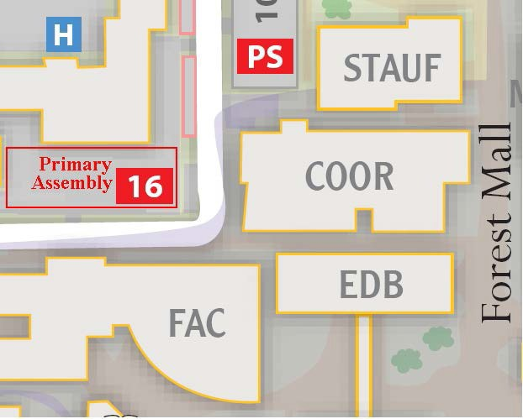

The designated Secondary Assembly area (used only if Primary Area cannot be accessed) for Lattie Coor, SHPRS, is located on the west side of Wilson Hall in between Payne Hall and Farmer Education building in the courtyard area.

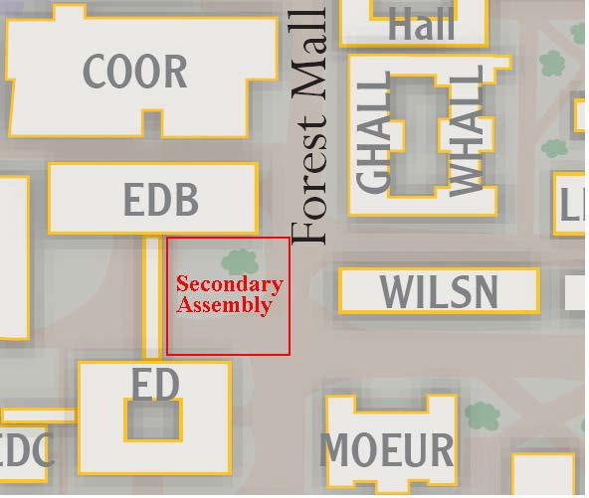

All occupants must reassemble at the designated staging area away from the building. Directors proceed with taking attendance of department employees to ensure everyone is accounted for. If it is known that someone is still in the building, notify the emergency response personnel (either ASU Police or the Fire Battalion Chief) with the information and their location within the facility.

Environmental Control/Misc Building Requests**:** To request temperature control, squeaking doors, leaky faucets, etc., email [SHPRSfrontdesk@asu.edu](mailto:SHPRSfrontdesk@asu.edu) to submit a service ticket to Facilities Management at <https://webtma-support.asu.edu/FDMServiceRequest/Default.aspx>. Urgent requests should be addressed via phone to 480-965-3644. (NOTE: As of August 2015, buildings are set to 78 degrees.)

Faculty Meetings**:** SHPRS holds three school-wide faculty meetings each semester. Reminders are sent a week prior to the meetings. In addition, each faculty holds its own disciplinary meeting lead by the disciplinary faculty heads.

Faculty Webpages**:** Ensure that no direct reproductions of copyrighted material are posted or to obtain the required permission to post those materials as needed. In most cases, simply linking to the journal or publisher website will be sufficient to direct the reader to an approved means of accessing the materials and will not invoke the ire of the publisher.

Guest Parking**:** SHPRS will validate parking for classroom guests, lecturers, and other non-ASU guests. If you will have a guest/presenter, please schedule a reservation at: [https://cfo.asu.edu/pts-guest-tempe](https://cfo.asu.edu/pts-guest-tempe%20)

Hour and full-day parking validation stamps may be obtained from Rachel Bunning. SHPRS will not reserve/validate/reimburse parking fees for faculty associates.

Laptops and Zoom Video Conferencing**:** Laptops for use in SHPRS seminar/conference rooms are available to borrow through the SHPRS front desk. An ASU ID is required for checkout.

ASU uses Zoom for video conferencing. For instructions on how to set up your account and log in visit <https://uto.asu.edu/zoom-resources>

General Supplies**\*:** A supply cabinet with general office supplies is located in the 3rd floor work room and 4th floor mailroom. (Please note that blue books are not provided.) Please help yourself to items as needed. We stock/provide only essential office supplies. Specialty items must be approved. For items requests, please complete the SHPRS Purchase Request form found in the SHPRS resource page, <https://shprs.asu.edu/faculty-and-staff-resources> and send to [SHPRSfrontdesk@asu.edu](mailto:SHPRSfrontdesk@asu.edu).

Lounge\***:** The lounges in room Coor 4577 and Coor 3313 offer amenities such as a refrigerator, microwave, toaster, sink, coffee pot, purified water, and couches and chairs. These are common areas which are best maintained when users clean up after themselves, and follow refrigerator etiquette. Please throw out any leftovers by 5pm Friday.

Mail\***:** The mailroom is located on the fourth floor, #4495. Faculty, staff, funded graduate students and faculty associates are assigned mailboxes in the mailroom. Mail is received and distributed daily by 10:00 a.m. There is only one pick up for outgoing mail. When large packages are received, a notice will be put in the recipient’s mailbox and the item(s) stored in the lower cabinets labeled History, Philosophy or Religious Studies. All USPS mail sent from ASU must go through ASU Mail Services. When you have packages to send out, please place them in or near the outgoing mail bucket in the mailroom, and mail services will pick them up. Be sure the following are on the packages:

1. Your ASU return address

2. The recipient address

3. Your nine-digit postal billing barcode (if it pertains to ASU business, otherwise please provide your own postage)

4. If these packages are not in US Priority Mail packaging, then place a note on them to be sent Priority Mail

Note: Put your name above the School address in case mail is returned.

The mailroom is kept locked during business hours. Please carry your keys with you for access to the mailroom. As of Summer 2019, keyless access to the SHPRS mailroom has been assigned to all new employees. Use your Sun Card to access the mailroom.

**\*Attention* COVID-19 Alert: Mailroom and Lounge services will be altered until further notice due to the pandemic. Please contact/see front desk staff for more information. Signs will also be posted on Mailroom and Lounge doors.**

New Employees/Onboarding**:** New employees are required to submit the [new hire packet](https://www.asu.edu/hr/forms/payrollpacket.pdf) to the main HR office, complete the Form I-9, elect federal and state tax deductions via MyASU, and enroll in the electronic delivery of your W-2, [enroll in the electronic W-2](https://cfo.asu.edu/fs-w2faqs).

To enroll in direct deposit**,**log into [My ASU](https://my.asu.edu/) and locate My Employment > Payroll > Direct Deposit and follow the instructions.

For benefits eligible employees, review your [benefits and retirement enrollment options](https://cfo.asu.edu/benefits-family-guides) and complete the enrollment process within 30 days of your hire date.

Mandatory Trainings**:**

All faculty, staff and student employees must complete the following training within 30 to 90 days from your hire date.

* Arizona public service policy | cfo.asu.edu/public-service-policy
* ASU information security training | getprotected.asu.edu/training/basics
* Community of Care Training | eoss.asu.edu/communityofcare
* Fire Safety and Prevention | cfo.asu.edu/ehs-training
* Preventing harassment and sexual violence | el.lawroom.com/shib/asu
* Title IX Duty to Report training | career-edge.asu.edu

Office/Building Keys/Keyless Door Access (ISAAC)**:** The process to request building/office keys is now an online process. To begin, please contact the Office Specialist via email for the key information you will need to complete your request. Once you have the necessary information, the key action request can be found at: [Key](https://webtma-support.asu.edu/ASUServiceRequest/Default.aspx) [Action Request Form.](https://cfo.asu.edu/key-lock-services) Keys must be picked up by the key holder at the Lock Shop which is located in University Services Building, 1551 N. Rural. Please take a copy of your confirmation email.

Lost keys must be reported to Front Desk staff as soon as possible. The key holder will be notified of any charges for replacement keys, the key holder is responsible for paying charges for lost/stolen keys. Loaner keys are available for check out thru the front desk in case of emergencies. If the loaner key is lost/stolen, the key holder is responsible for the $7 replacement fee, payable to SHPRS.

Keyless Door Access System (ISAAC) As of Fall 2020:

* Keyless entry codes replaced keys to unlock the **shared conference rooms**: 4403, 4401, 4411, 4481, 4581, 3301, & 3323. Please use code ‘172301’ to unlock these doors. If you need assistance, please see front desk or email [SHPRSFrontDesk@asu.edu](mailto:SHPRSFrontDesk@asu.edu).
* Keyless access to the SHPRS mailroom will be assigned to all new employees using their ASU issued Sun Card. If you need assistance contact Office Specialist.

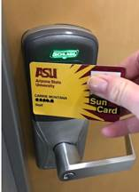Access to a door controlled by ISAAC is requested by contacting the Office Specialist. You will need your ASURITE ID and Sun Card information to authenticate when requesting. **Processing a new request can take up to five working days**, especially at the beginning of a semester.

Student access expires and must be renewed three times per year.  The procedure for renewal is the same as a first-time request.  The expiration dates are always the same for each year:

SUMMER: Aug 15

FALL: December 31

SPRING: May 15

Office Supplies**:** General office supplies can be found in the mailroom in the wooden cabinet in the workspace off to the left side in the mailroom.

#### **Payroll Dates**: There are 10 pay periods per semester and 6 pay periods in summer. For a list of pay periods and pay dates visit <https://cfo.asu.edu/academic-pay-schedule>

#### **Personal Safety and Security**:

Sign up for [ASU Alert and Advisory System](https://cfo.asu.edu/emergency-alert) to receive updates and instructions. The campus offers safety escort services after 7pm. They can be reached at (480) 965-1515. The [ASU hotline](http://audit.asu.edu/asu-hotline) for Ethics and Compliance is an anonymous reporting tool. Campus police can be reached by dialing 911 from any office phone, or dialing (480) 965-3456.

Printer Resources**:** Through the **ASUPRINT1** resource alliance, SHPRS can meet printing and copying needs while aligning with ASU’s sustainability goals and initiatives. Faculty, staff and funded graduate students use the School printers located on the Third and Fourth floors of Coor Hall. The Canon machine in the mailroom will require a Dept ID number to print and you will use the last 4 digits of your ASU ID# (no pin required).

When print jobs are in excess of 200 pages, please utilize the services of [Print U](http://printcpc.com/digitalu/index.php?option=com_content&amp;amp%3Bview=article&amp;amp%3Bid=4&amp;amp%3BItemid=4) at the Memorial Union so that our School resources are preserved for normal copy and scanning requests. *This initiative replaces the purchasing of replacement toner and ink for office/desktop printers.* Users choosing to continue using existing desktop printers are responsible for providing their own ink cartridges. As old desktop printers break down, they will not be replaced as users have access to several printers throughout SHPRS.

For service on SHPRS copiers, call the Canon Help Desk at 480-965-2679, select option #2, provide device serial number.

Recycling**:** The blue bin program aims to increase recycling participation and to reduce contamination of [recyclable materials.](https://cfo.asu.edu/fdm-recycling-at-asu) There is an open bin on the fourth floor north landing. The bin is for flattened boxes only; it is not for paper/books/magazines, etc., as these items require a closed bin. If you need a closed roll-away bin for paper/books/magazines, please email [Recycle-Q@asu.edu](mailto:Recycle-Q@asu.edu). Putting items other than flattened boxes in the bin delays the return of the bin to its location.

Room Reservations Seminar/Conference Rooms**:** Each floor of SHPRS has at least one School owned seminar room and/or multiple shared conference rooms. Seminar rooms are first used to schedule undergraduate/graduate seminars after which the rooms become available for general ASU classroom scheduling. If you would like to reserve a room/equipment, please email [SHPRSFrontDesk@asu.edu](mailto:SHPRSFrontDesk@asu.edu) as soon as you know your date(s), also include time, approximate number of people, short description, contact person, & equipment needs. SHPRS staff will confirm room availability and confirm your reservation and send an Outlook invite. The scheduling is for internal events such as class breakout sessions, study groups, faculty/staff meetings, etc. *Please note that code ‘172301’ will open/unlock all shared conference rooms including #4411 and #4403.*

For questions about reserving rooms, contact the front desk at [SHPRSFrontDesk@asu.edu](mailto:SHPRSFrontDesk@asu.edu).

**\***

|  |  |
| --- | --- |
| **Room** | **Capacity Estimates** |
| **3301\*** | 24 at table |
| **3323\*** | 15 at table, 25 chairs |
| **4401** | 23 at table, 30 chairs |
| **4403\*** | 25 at table, 50 chairs |
| **4411\*** | 14 at table, 20 chairs |
| **4481\*** | 8 at table, 10 chairs |
| **4581** | 14 at table, 20 chairs |
| **\* Working Projector Installed** | |

**\*Attention* COVID-19 Alert: Room capacities will be determined based on social distancing guidelines and therefore will be determined on a case by case basis. Please contact/see front desk staff for more information.**

School e-mail Distribution lists**:** Below are the various distribution lists for SHPRS. Please notify Erica May if you have difficulties with any of the lists.

dl.org.la.shprs.fac (all SHPRS tenured/tenure track faculty, lecturers, instructors) dl.org.la.shprs.tenured (all SHPRS tenured/tenure track faculty)

dl.org.la.shprs.staff (SHPRS staff)

dl.org.la.shprs.fa (all SHPRS faculty associates)

dl.org.la.shprs.lecturers (all SHPRS lecturers)

dl.org.la.shprs.instructors (all SHPRS instructors)

dl.org.la.shprs.grads (all SHPRS graduate students)

dl.org.la.his.fac (History only tenured/tenure track faculty, lecturers, instructors) dl.org.la.shprs.hsttenured (History only tenured/tenure track faculty)

dl.org.la.his.gs (History only grad students)

dl.org.la.phil.fac (Philosophy only tenured/tenure track faculty)

dl.org.la.shprs.phitenured (Philosophy only tenured/tenure track faculty)

dl.org.la.phil.gs (Philosophy only graduate students)

dl.org.la.rel.fac (Religious Studies only tenured/tenure track faculty, lecturers) dl.org.la.shprs.reltenured (Religious Studies only tenured/tenure track faculty) dl.org.la.rel.phdgrads (Religious Studies only graduate students)

#### 

## Staff and Faculty Parking:

Personnel are responsible for arranging their own parking accommodations. New employees are offered a temporary parking pass through New Hire Orientation. You can contact the [parking &](https://cfo.asu.edu/pts) [transit](https://cfo.asu.edu/pts) services at 480-965-6124. A [map of the tempe parking structures](http://www.asu.edu/parking/maps/tempe-current.pdf) identifies the lot numbers. For more information on public transit, ride sharing, cross parking, shuttles, and to purchase parking permits, visit <https://cfo.asu.edu/pts>.

Sun Cards**:** The Sun Card is free (first time) for all benefits eligible faculty and staff. Cards are typically issued during new employee orientation. Replacements cost $25. To replace a card, visit the ASU Sun Card Office at the Memorial Union, #58 (lower level).

Telephone Service Report**:** Telephone service requests are submitted through [MyASU>Service>Service Catalog>Communication and Collaboration>Telephony>Phone Services](https://asu.service-now.com/sp?id=sc_category&sys_id=37f15a1f1390774075e9b4a76144b09a).

Trash Pickup**:** As of August 2019, office trash is picked up once a week.

Updating Directory Information/Personal Information**:** Remember to keep your ASU Directory profile and personal information current. To update information, log on to your MyASU and select “Profile.” Make changes needed to Biography, Research Interests, picture, or CV. Links to personal pages should be provided through ASU Directory pages. To update personal information, scroll down to Contact Details under Profile and click on the area you want to update (Work Address, Home Address, Emergency Contact, etc.).

iSearch**:** All ASU faculty and staff members are required to have an iSearch profile in order to provide a more cohesive, easily navigable directory. The updated iSearch format is more flexible, with discrete sections for much of the information that was previously bundled together.

Requirements:

Photo

Email

Campus address

Phone number

Expertise areas (at least 3)

Biography (100-300 words, 3rd person)

Short biography (40-word limit, 3rd person. Use last name only in this text, if used.)

Education (required for faculty only)

CV (required for faculty only)

For more information on ASU brand standards and instructions, visit the [brand guide site](https://brandguide.asu.edu/web-standards/isearch-profiles).

Work Orders**:** If you have copying or other work requests for the front desk staff and/or student workers, please send your request to [SHPRSFrontDesk@asu.edu.](mailto:SHPRSFrontDesk@asu.edu) Be sure to include all information necessary to complete your work request. An acknowledgement email will be sent to you when your work request has been received and another sent when your job is complete. If you are unable to send your work request electronically, please complete a work order form and place in the “Work Orders” bin on the counter in the mailroom/workroom. *Note that class handouts are to be made available to students online.* Office staff can scan your original and email to you so that you can upload to Canvas/email to your students. Please allow at least two working days in which to complete all work requests.

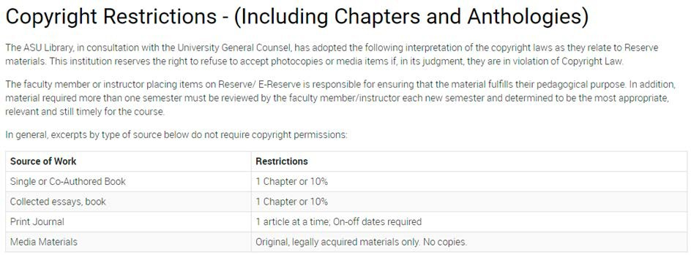

University Holiday**s**: Administrative offices are open during summer, fall, winter, and spring breaks. For a list of university holidays and closures visit <https://cfo.asu.edu/holiday-schedule>

# BUSINESS – EVENTS – RESEARCH FUNDING

Academic Personnel Actions: Prior to the start of the academic year, notifications will be sent out to faculty regarding upcoming reviews, promotion & tenure, and promotion. Visit the [Guide to Faculty Reviews at ASU](https://thecollege.asu.edu/sites/default/files/guide_to_faculty_reviews_at_asu_assistant_professorv2.pdf) for an overview of the processes.

Annual Faculty Reviews take place typically during the start of the spring semester. Notifications will be sent in early January detailing the required information and deadline.

Hosting/Coordinating Faculty Event**:** Each Discipline in SHPRS has a budget of for its annual

faculty-level events. Funds not used by May 30, of current fiscal year revert to the School.

Faculty members serving as hosts and/or coordinating a faculty event should work with

Rachel Bunning (rebunnin@mainex1.asu.edu) to plan their event(s). To request assistance with your event, please use the [Events Request Form](https://clas-forms.asu.edu/shprs/request-special-event-support). Things to keep in mind as you plan your faculty event:

* **Reserve Conference Room*:*** through SHPRS room reservation process [SHPRSFrontDesk@asu.edu](mailto:SHPRSFrontDesk@asu.edu) or more information on this process, see section on Room Reservations.

**\*Attention* COVID-19 Alert: Room capacities will be determined based on social distancing guidelines and therefore will be determined on a case by case basis. Please contact/see front desk staff for more information.**

* **Food**:
  + Option 1: Can be purchased by host and expense reimbursed. Complete [Business Meal Expense form](https://shprs.asu.edu/sites/default/files/business_meals_form_shprs.pdf), attach receipts and submit to staff for reimbursement. No alcohol.
  + Option 2: Host can work with ASU Catering to identify menu. Catering will prepare an invoice, which can be submitted to SHPRS staff for payment. Catering website: [SunDevil Caterin](https://sundevildining.asu.edu/catering)g
* **Honorarium**:
  + - Host is to complete the [honorarium request form](https://clas-forms.asu.edu/shprs/request-honorarium). Please see Rob Cochran if you have any questions on how to complete the form. Guest completed forms should be submitted to Rob Cochran processing, [Rob.Cochran@asu.edu](mailto:Rob.Cochran@asu.edu). **Forms should be completed and submitted at least one month before visit to allow for timely processing.**
* **Airfare**: Please email [SHPRSFrontDesk@asu.edu](mailto:SHPRSFrontDesk@asu.edu) for guest travel arrangements.
  + Personal payments for airfare/hotel/other guest expenses cannot be made and will not be reimbursed. Per ASU policy, FIN 401-03, such payments are considered prepayment and violate policy. Please work with business staff on these expenses.

Institute for Humanities Research**:** From the IHR website (<http://ihr.asu.edu/home>): “The role of the Institute for Humanities Research in the New American University is to advance the humanities as a site of vital research that contributes to productive social dialogue and makes a difference in the world. The IHR generates and supports transformative, transdisciplinary, collaborative, and socially engaged humanities scholarship that contributes to the analysis and resolution of the world’s many challenges”. The IHR research advancement staff assists faculty with sponsored projects in the following ways:

* Pre-Award: Search for funding, assist with budget preparation, narrative reviews and edits, prepare the necessary documents for sponsor submission and serve as liaison to Office of Research and Sponsored Projects Administration (ORSPA).
* Post Award: Assist with communications with ORSPA, review expenses, manage cost share, answer post award questions, process budget revisions and no cost extensions, assist with sub-awards, process paper work for ORSPA submissions and handle the close out of the award.
* Interact with faculty home unit business staff to resolve budget issues with expenses and payroll. Inform staff of new awards and provide budgets.

Any externally funded proposals need to be properly routed through the University system and approved by SHPRS, The College, and ORSPA before it can be submitted. ASU has the option to reject grants that were not submitted through the proper channels.

Please contact Becky Tsang or Sheila Hoyle (IHR) when you are considering submitting an application.

Independent Contractors**:** Independent contractors are used when a service or expertise is not available at ASU and is required to carry out university business. Please check [SunMart](https://cfo.asu.edu/sunmart) first to see if the contractor is already approved to work with ASU. Per policy, independent contractor services must be approved *prior to* the assignment. The approval process can take up to 12-15 business days so it is important to plan ahead. Work with Rob Cochran, [Rob.Cochran@asu.edu](mailto:Rob.Cochran@asu.edu) or Carrie Montana, [cmontan7@asu.edu](mailto:cmontan7@asu.edu). Policy prohibits paying for services out of pocket and then submitting for reimbursements. Such requests will not be accepted or processed. Please submit a quote for services to the business office and a point of contact for supplier registration set up. Complete the required form, [Employee/Independent Contractor Determination Checklist.](https://www.asu.edu/fs/forms/independent-contractor-checklist.pdf)

Leaves Management**:** The Business Office will coordinate with OHR (Office of Human Resources) to submit all leaves of absence. Leaves may be categorized as one or more of the following: FMLA, ASU Leave, Military, Personal and Parental Leave. Please contact Rob Cochran or Yvonne Delgado to begin the leaves process. For paid/unpaid leaves due to fellowships contact Yvonne Delgado.

For more information regarding the leaves available and updated policies visit:

Faculty - Academic Affairs Manual – ACD 700 Leaves and Absences

Staff – Staff Personnel Manual - SPP 700 Leaves and Absences

Purchases**:** Per [PUR 201-01,](http://www.asu.edu/aad/manuals/pur/pur201-01.html) all university procurements, *regardless of funding source* (e.g., local account, research funds, grant funds, IIA funds, Foundation funds, or startup funds) are to be made in accordance with applicable state statutes, federal regulations, Board of Regents’ policies and university policies. The SHPRS [Purchase/Expense Reimbursement](https://shprs.asu.edu/sites/default/files/purchase_request_form_shprs.pdf) form is to be used for purchases or reimbursements. Complete the form at least ***2 weeks in advance***of purchases and submit to Rob Cochran. Do not purchase equipment with personal funds and submit for a reimbursement. All purchases and payments are to be processed through the SHPRS business office to ensure compliance with policy and use of contracted vendors. If in doubt, consult with the business office staff when planning a purchase.

Recruitment and Hiring**:** Student workers are limited to working a rolling average of 25hrs per week during the academic year. International students are limited to working 20hrs during the academic year. Student workers can be hired using general operating, local, gift, and research funds (if allowable on grant).

To hire a student worker, complete the [SHPRS hire form](https://shprs.asu.edu/sites/default/files/shprs_hire_form.pdf) found on the SHPRS resource page and send to Rob Cochran, [Rob.Cochran@asu.edu](mailto:Rob.Cochran@asu.edu).

Staff hires require Dean and Provost approval. Contact Yvonne Delgado, [Yvonne.Delgado@asu.edu](mailto:Yvonne.Delgado@asu.edu) to begin the approval and hiring process.

Faculty Searches – Faculty search chairs are designated by Dr. Amesbury, Director. Faculty searches are administered via Interfolio. Yvonne Delgado manages Interfolio for SHPRS, the required paperwork, and posts the ads on the Chronicle of Higher Education job site and designated professional associations job listing sites. Visit [The College recruitment](https://thecollege.asu.edu/resources/academic-personnel/tenure-track-personnel/recruitment-hiring) site for more information.

Reimbursements**:** Authorized business expenses incurred on behalf of ASU must be accounted to ASU within 7-60 days. See [FIN 420-01: Faculty and Staff Reimbursements: Accountable Plan](http://www.asu.edu/aad/manuals/fin/fin420-01.html) [Rules](http://www.asu.edu/aad/manuals/fin/fin420-01.html) for the rules required so as to not have the reimbursement amount not included in taxable compensation. If rules are not met, the amount to be reimbursed is treated as taxable compensation.

Employees are the first approver in the Workday accounting system for expense reimbursements – accessed through My ASU - click on the “Employment” tab, scroll to the “Financial Tools” box in which there is a link to “Financial Management System”. You will see the items to approve in your Workday Inbox.

SHPRS [Purchase/Reimbursement Form](https://shprs.asu.edu/sites/default/files/purchase_request_form_shprs.pdf) (see Appendix 2) must accompany all requests for purchases or reimbursements. The only exception is for reimbursement of business meals when only the [Business Meals and Related Expenses Form](https://shprs.asu.edu/sites/default/files/business_meals_form_shprs.pdf) is required. See Appendix 1 for a sample business meal form.

See [FIN 401-03: Prohibited Transactions](http://www.asu.edu/aad/manuals/fin/fin401-03.html) for a list of prohibited transactions that cannot be processed as reimbursements.

**Provide all original itemized* receipts *(taped onto an 8.5x11 sheet of paper using single side of paper)*, staple to a completed** [**SHPRS Purchase-Reimbursement**](https://shprs.asu.edu/sites/default/files/purchase_request_form_shprs.pdf) **form, and submit to Rob Cochran for processing.**

Payments for services (e.g., honorariums, independent contractor payments, reimbursements of expenses incurred by independent contractors) are not to be paid directly by faculty/staff. Such requests will not be reimbursed. Please use the [Request for Honorarium](https://clas-forms.asu.edu/shprs/request-honorarium) web form to pay honorariums. See Rob Cochran or Carrie Montana for documentation required for payment of other service providers or reimbursements for independent contractors.

KEEP IN MIND:

* + Documents not properly submitted will be returned to the requester.
* Reimbursements over $1,000 should be avoided, they require additional approvals by the Dean and Provost and are limited to a few exceptions. Please contact Rob Cochran for purchase requests.
* Meals must not exceed $40/person, before tip. Tips are limited to 20% of bill. Overages will not be reimbursed.
  + Alcohol expenses will not be reimbursed.
  + ASU policy states itemized receipts are preferred and may be required in certain circumstances prior to issuing reimbursement. The best practice is to always submit itemized receipts. ([FIN 420-02](http://www.asu.edu/aad/manuals/fin/fin420-02.html))
  + Below are examples of unacceptable and acceptable public purpose statements for consideration when submitting a SHPRS Purchase/Reimbursement/Payment form:
    - Unacceptable public purpose statement: Catering for staff meeting.
    - Acceptable public purpose statement: Catering for fall semester staff meeting to promote unit morale and to discuss strategic planning for unit thru lunch.
    - Unacceptable public purpose statement for purchase of a book: Book purchased
    - Acceptable public purpose statement: Purchased book for Prof. James to reveal the latest trends and direction of research developments within the field of … in order to assist with future recommendations for ASU to pursue.

Sabbaticals**:** [Sabbatical applications](https://provost.asu.edu/sites/default/files/page/1562/process-guide-sabbatical-leave-aps-20190613.pdf) and required documents are due at the beginning of the fall semester. Notifications are sent to eligible faculty. The following personnel are eligible to apply for sabbatical leave:

* + Administrators with faculty rank who have completed six years of full-time service at ASU.
  + Faculty members who have achieved tenure and completed six years of full-time continuous service with the rank of assistant professor or higher at ASU.
  + Academic professionals who have achieved continuing status and completed six years of full-time continuous service at ASU are eligible to apply for sabbatical leave.

The [Report on Sabbatical leave form](https://provost.asu.edu/academic-personnel/personnel-processes/academic-personnel-forms) must be submitted to [Yvonne.Delgado@asu.edu](mailto:Yvonne.Delgado@asu.edu) no later than the end of the first semester after completing the sabbatical leave.

Sick/Vacation time**:** Benefits eligible employees accrue sick leave. Benefits eligible faculty on fiscal year appointments as well as staff accumulate vacation time. To view leave balances, go to MyASU > My Employment > Time.

To report sick time or vacation time go MyASU > My Employment > Time > Time and Leave Reporting. Prior approval from the employee’s immediate supervisor is required. Send approvals of time off via email to [Yvonne.Delgado@asu.edu](mailto:Yvonne.Delgado@asu.edu) prior to the time taken. Full-time SHPRS staff also report hours in TAS. See Yvonne Delgado for more information.

Staff Evaluations: ASU EDGE Conversations are meant to help employees and their supervisors focus on goals, areas of concern/problems, and achievements. Every three months, employees will complete their portion of the [Edge Conversation form](https://shprs.asu.edu/sites/default/files/shprs_asu_edge_conversation_summary_form.pdf). After receiving that partially filled out form, the supervisor is to complete their portion and schedule a time to review the form together. For more information, contact your supervisor or visit the [Canvas training course page](https://canvas.asu.edu/courses/16498).

Start-up Funds**:** Start-up funds are negotiated at the time the tenure-track faculty appointment is offered.If negotiated, new Tenure-Track faculty receive startup funds for their first three years of appointments. The funds are to be used to further their research. The faculty are sent a budget sheet to complete each year estimating the amount to be used for the fiscal year. The faculty will meet with the Assistant Director or Business Office Manager to finalize the budget. Typically, funds are allocated from the dean’s office as general operating funds— meaning they must be spent by June 30th. Any funds not used will be lost. Please work with the business manager if you have any questions as you create your annual budgets and/or if unforeseen circumstances will prevent you from spending all of your annual startup funds. Should funds be allocated as local funds, any unspent funds will roll over into the following fiscal year. Expenses on local funds are subject to the university 8.5% ASC fee.

Travel**:** SHPRS provides *all faculty* with *a* travel allowance every school year.

* + Travel funds can be used for research trips, conference participation, professional meeting attendance, etc. and can be split into multiple trips
  + Travel funds must be used within the current academic year. Unused funds do not roll over from one year to the next
  + Travel funds may not be transferred to another traveler
  + Travel funds are to be used for travel only; they cannot be used for other purchases (e.g., equipment)

#### Travel must be completed and expense claim submitted by June 30th of the current fiscal year

**\*Attention* COVID-19 Alert: International travel is currently prohibited (Dated June 26, 2020). As applicable, all travelers, whether on overnight or single day travel, must follow the**

**ASU travel policy, ASU Domestic Travel guidance, and [COVID-19 guidelines for ASU](https://research.asu.edu/covid-19)**

**[researchers](https://research.asu.edu/covid-19).**

Please use the [My ASU Trip Quick Reference Guide](https://www.asu.edu/fs/documents/my-asu-trip-quick-reference-guide.pdf) for assistance. [My ASU TRIP](https://cfo.asu.edu/myasutrip) provides links to instructions on how to update a profile, create a trip request, book travel, and complete an expense report. You will also find the Trip Manual and Travel Policy for your review.

***TRIP REQUEST - Before you leave, you must submit a Request in MyASU Trip/Concur***

1. Check with SHPRS Business Office about your available funding for the fiscal year. Documentation is required when accessing travel funds awarded above and beyond the annual allotment per faculty member. ***Use account PG03577*** for standard SHPRS Travel allotment. If you have additional funds available and are unsure of your account, please check with Carrie Montana. *Travel authorization cannot be approved without supporting documentation attached and/or comments entered on trip request*
2. Complete the online travel form at: <https://cfo.asu.edu/myasutrip> an approved travel request must be on file ***prior*** to departure
3. The Auditor General’s Office requires that the travel authorization state the public purpose being served (example, presenting at a conference, conducting research at archive, etc.).
4. Upload your conference brochure
5. If renting a car instead of airfare, provide proof that car rental is less than airfare. See page regarding [car rental](https://www.asu.edu/fs/travel/Auto-rental-liability.pdf).
6. List Montana, Carrie as Cost Center Manager and Tsang, Becky as ATO
7. In the comments box, include how your class(es) will be covered if travel occurs during class time
8. If you are combining business and personal travel please review Personal Time with Business Travel guide for best practices, see Appendix 5.

#### [How do I handle a zero-dollar trip in MY ASU Trip?](https://cfo.asu.edu/faq/3998) ASU employees who travel on official ASU business, but are funded from another organization where no reimbursements are made must submit a zero-dollar trip request prior to the start date.

***BOOKING TRAVEL – Arranging for travel after your trip request is approved***

Travel arrangements should utilize the most economical method of transportation in terms of expense to the university and the traveler's time away from the office. Utilizing the online booking tool within My [ASU TRIP](https://cfo.asu.edu/myasutrip) or calling the university's contracted travel agency are the preferred methods of booking travel. If renting a car for business travel faculty and staff must use an approved [vehicle rental contract](https://cfo.asu.edu/sunmart) and complete the [Authorized Driver Program](https://cfo.asu.edu/authorized-driver-program). If My ASU TRIP or the contracted travel agency are not used, the traveler should load his or her flight itinerary in My ASU TRIP to support the university's duty of care (to help ASU contact the traveler in case of emergency).

If traveling to an international destination, [ASU Travel Policy Standard 3](https://www.asu.edu/aad/manuals/fin/fin501.html) should be reviewed prior to committing to a trip. The traveler is responsible for obtaining the proper passports or visas and following specific requirements for travel on Grant Accounts ([RSP 504-01: Sponsored Projects Travel for ASU Employees](https://www.asu.edu/aad/manuals/rsp/rsp504-01.html)). If a passport is required for authorized university business travel and the traveler does not already have a passport, the expense is an authorized reimbursable travel expense. The cost of a visa and associated fees are authorized reimbursable university business travel expenses. If these purchases are not on an ASU Travel Card, receipts are required for reimbursement.

Car Rental -faculty and staff are required to rent through the approved purchasing vehicle rental contracts. If a traveler rents off the contract they may be held liable for any cost incurred if there is an accident. Car rental information can be found at <https://cfo.asu.edu/sunmart#accordion-embed_1-2>.

The traveler is responsible for obtaining any required immunizations or international medical insurance, and the fees for these are reimbursable business travel expenses with a receipt.

When faced with conflicting federal, sponsoring agency, or ASU travel policies, the more restrictive policy is followed. However, to ensure the consistent and equitable treatment of all ASU travelers, if the restriction results in a lesser reimbursement from a sponsored account, the department should consider covering the difference from a non-sponsored account, per [*ASU Travel Policy Standard 4: Arranging for Travel.*](https://www.asu.edu/aad/manuals/fin/fin501.html)

***EXPENSE REPORT - When you return, process an Expense in MyASU Trip/Concur for reimbursements***

Within one week of travel completion, you must do the following:

1. Log into your trip online and open your trip request to complete the actual expense portion of the online travel claim. Actual expenses should not total more than the amount of funding authorized.
2. All receipts must be uploaded at time the actual expenses are entered.

Per ASU travel policy, travelers are allowed ***30*** calendar days following their trip-end date to submit all supporting documentation and receipts to Travel Reimbursements for

processing. *However, to allow time for SHPRS staff to perform the first level audit, receipts and trip summary should be submitted in Concur within 20 days following your trip-end date (add Montana, Carrie as Cost Center Manager).*

If the expense report with all pertaining documentation is not submitted into Concur and in a timely manner, the Travel Office 30-day policy will be violated. In such cases, a late reminder will be sent directly to the traveler via email notifying the traveler. At ***45*** days past trip-end date, a second late reminder will be sent and additionally at ***60*** days, notification will be sent and may result in a notification of the senior fiscal administrator in the applicable college or VP area. If any amounts were advanced or charged to the ASU Travel Card a payroll deduction may be necessary. Email travel related questions to [SHPRS.Travel@asu.edu.](mailto:SHPRS.Travel@asu.edu)

Travel Without an Overnight Stay: A traveler who requests reimbursement for expenses related to in-state travel without an overnight stay, such as mileage, parking and meals, must use the Reimbursement for [Mileage, Parking, Taxi and Car Expenses form](http://www.asu.edu/fs/forms/AP_Reimb_MileageParkingTaxi.pdf) on the Financial Services website. This can be completed online and submitted to the SHPRS Business Office for reimbursement.

Travel Instructions – Zero Dollar Trip (For Insurance Purposes Only):

ASU employees who travel on official ASU business but are reimbursed from another organization for their travel expenses or, in some cases, no reimbursement is made. A traveler must submit a zero dollar travel trip request prior to the start date. The zero dollar trip indicates that the authorization is for approval to travel and insurance purposes only. The date, destination, purpose of the trip, and any source of funding must be noted on the trip. In case of an accident, the filing of the trip does not guarantee acceptance by workers’ compensation of official ASU travel status; however, it does provide additional pre-accident documentation of the reason and intent of the trip.

COVID-19 Travel Reimbursement Update**:** Airlines are offering full refunds (not just airfare credits) for flights they cancelled due to the pandemic. If you purchased a ticket (paid personally out-of-pocket) that you later cancelled because of the ASU travel restriction, you are eligible. (Clarification: if the passenger did NOT cancel with the airline prior to the flight time (no-show), they are NOT eligible for a refund or a credit.) To receive a refund you must reach out to the airline. Below are some websites you can check to see if you have a refund available for any flights that were cancelled by the airline. If your flight was purchased through Concur/Anthony Travel/ASU Travel, the travel office has already checked for refund eligibility.

Important note: If you received reimbursement for a flight that was cancelled, please reach out to the airline to request for funds to be paid back to ASU. If a refund is not possible and a credit is issued instead, the full value of the ticket will likely be available to be used in the future for any employee (without change fees). SHPRS is required to track each of these credits so that they are utilized in full for future ASU business.

Websites to apply for refunds:

[www.southwest.com/coronavirus/](http://www.southwest.com/coronavirus/)

[www.aa.com/i18n/travel-info/coronavirus-updates.jsp](http://www.aa.com/i18n/travel-info/coronavirus-updates.jsp)

[www.delta.com/us/en/travel-update-center/overview](http://www.delta.com/us/en/travel-update-center/overview)

<https://hub.united.com/united-coronavirus-covid19-safety-update-2645397564.html>

[www.expedia.com/lp/coronavirus-travel](http://www.expedia.com/lp/coronavirus-travel)

<https://news.marriott.com/all-news>

[www.hilton.com/en/corporate/coronavirus/](http://www.hilton.com/en/corporate/coronavirus/)

# 

# ACADEMIC/TEACHING RESOURCES - STUDENT SERVICES

Academic Integrity:Academic honesty is expected of all students in all examinations, papers, laboratory work, academic transactions and records. The possible sanctions include, but are not limited to, appropriate grade penalties, course failure (indicated on the transcript as a grade of E), course failure due to academic dishonesty (indicated on the transcript as a grade of XE), loss of registration privileges, disqualification and dismissal. For more information, see <http://provost.asu.edu/academicintegrity>.

The grade of "XE" denotes failure due to academic dishonesty and is treated the same as an "E" for the purposes of GPA, course repeatability, and academic standing determination. A student may not avoid any penalty for academic dishonesty by withdrawing from a course.

Policies along with informational resources for faculty/students in The College can be found here: <https://thecollege.asu.edu/resources/academic-integrity-resources>.

To report possible academic integrity violations, use this form: <https://clas-forms.asu.edu/content/faculty-academic-integrity-violation-report-form>.

The College contact for academic integrity issues is Amanda Smith, [Amanda.A.Smith@asu.edu](mailto:Amanda.A.Smith@asu.edu).

Procedures for withdrawing students for disruptive behavior can be found here: <http://clas.asu.edu/advising-and-academic-services/procedures-withdrawing-students-disruptive-behavior>.

Cancelling Class**:** When illness requires you cancel your class(es), please call the main desk (480-965-5778) or send an email to [SHPRSFrontDesk@asu.edu](mailto:SHPRSFrontDesk@asu.edu) to advise staff of the cancellation. A notice will be posted on your classroom door.

Class Assignment Drop off**:** If you allow student assignments to be dropped off at the front office, instruct your students to include the following information on the face page:

* Instructor name
* Course
* Student name

Failure to include the information will result in delayed delivery or no delivery at all. Instruct students to date/time stamp assignments using the time clock on the front counter and to leave the assignment in the bin located next to the time clock on counter at the main desk. Assignments will be delivered to faculty mailboxes throughout the day. Please return assignments during class or during office hours. Do not leave papers/assignments in your mailbox, in office door bins, boxes, or at the front desk as doing so violates FERPA policy.

Commencement/Convocation Ceremonies**:** Commencement and Convocation ceremonies are held at the end of each Fall and Spring semester. The undergraduate academic advisors are expected to work at The College convocation ceremony in various roles, including graduate check-in, seating coordinator, and banner carrier/Dean’s Medalist guide.

Faculty will be identified each semester for participation via email by The College.

Course Evaluations**:** Course evaluations are conducted each semester and summer session. Evaluations are completed online. Faculty and students will receive notices at the start of each evaluation period. Faculty are encouraged to remind their students to complete evaluations.

Faculty may allow time during class for students to complete their evaluation on laptops/smart phones. Results will be made available to faculty, through MyASU, after evaluations have been reviewed by SHPRS administration and after all final grades have been posted.

Course Overrides**:** Students may contact faculty to request permission to take a course that is full, or for which they do not meet prerequisites. For undergraduate courses, if you approve the request, the student (or you) will need to send that approval to SHPRS Advising through this [online form](https://clas-forms.asu.edu/clas/clas-course-override-form) or by e-mailing [SHPRSAdvising@asu.edu](mailto:SHPRSAdvising@asu.edu). If e-mailing, please include Student name, student ID, Course Number and Prefix (e.g., HST XXX), and five digit course number. An advisor will then place the override and contact the student. If you need more information to make your decision about the override, please e-mail [SHPRSAdvising@asu.edu](mailto:SHPRSAdvising@asu.edu) to reach any of the undergraduate advisors. For on-campus courses, section full overrides cannot be placed if the classroom is already filled to capacity (per fire code). The advisors verify classroom capacity before placing overrides.

Course Scheduling**:** For general questions regarding course schedules, including course title, room change, cross-listing, and accessing the class roster, email Marissa Timmerman, [Marissa.R.Timmerman@asu.edu](mailto:Marissa.R.Timmerman@asu.edu).

School Meetings**:** SHPRS holds three school-wide meetings per semester. Per School bylaws, announcement of meetings will be sent seven working days in advance with a proposed agenda distributed at that time. A final agenda will be distributed at least 24 hours in advance of the meetings. The final agenda may include items submitted by faculty members received five working days in advance of meeting. Minutes will be kept in a manner consistent with Robert’s Rules of Order and will be posted on Canvas in a timely fashion. Attendance is expected as part of faculty service obligations. If attendance is not possible, please notify Becky Tsang prior to the meeting date.

Each faculty holds its own meetings as well. Faculty Heads schedule/coordinate the discipline-based meetings. Faculty Heads will ensure that minutes are recorded and posted on Blackboard.

Finals**:** Final exams must adhere to the final exam schedule made available each semester. If a

conflict occurs or if a student has more than three exams scheduled for the same day, the instructor can be consulted for an adjustment. Otherwise, and per policy 304-01, requests for early exams may not be granted by the class instructor. The dean of the college in which the student is enrolled must review all requests for early final exam dates.

Grade of EN**:** The grade of "EN" denotes failure due to student never participating in any academically related activity for a course and is treated the same as an "E" for the purposes of GPA, course repeatability, and academic standing determination. If a student never attended, logged into, or participated in your course in any way, please assign the grade of “EN” rather than “E,” as the “EN” assists ASU in determining a student's financial aid eligibility. For more information, please click [here](https://shprs.asu.edu/sites/default/files/en_grade_emailandfaqs_to_deans_14november2016_final.pdf).

Incompletes**:** Review the Registrar explanation of an “incomplete” grade here, [https://students.asu.edu/grades#grading](https://students.asu.edu/grades#grading_). A mark of "I" (incomplete) may be given by the instructor when the student is otherwise doing acceptable work but is unable to complete the course because of illness or other conditions beyond their control.

Per policy, SMM 203-09, a grade of Incomplete should be granted only when the student can complete the unfinished work with the same instructor. The student must arrange completion of the course requirements with the faculty member. Both the faculty member and student must complete a Request for Grade of Incomplete form. Turn in the completed form

to SHPRSAdvising@asu.edu.

Students have one calendar year from the date the grade of “I” is recorded to complete the course. The instructor may establish an earlier deadline if needed (for example, if the instructor will be on sabbatical within the next year, an earlier deadline may be required). If the student completes the course within the calendar year, the instructor submits the grade change using the Faculty Center.

The student must NOT re-enroll in the course in a future term as a way of making up the grade. This opens up a second instance of the course on the student’s record. Instead, the student needs to work with the instructor to make up the missing work, and then the instructor will submit a grade change for the original course. If the student needs to use the online course platform to complete work (especially in the case of i- or o-courses), they should continue using the platform from the original course.

In the rare event that the grade of incomplete was not initiated by the student, please ensure the student has been informed you are assigning a grade of “I.” Some students don’t check their grades in a timely manner. The Request for Grade of Incomplete form will clarify to the student exactly what needs to be done to complete the course.

Questions? Contact the Undergraduate Advising Manager or SHPRSAdvising@asu.edu.

Individually Arranged Courses**:** The individually arranged course [form](https://shprs.asu.edu/sites/default/files/individually_arranged_courses_form.pdf) is used for 499 independent studies or 492 & 493 honors thesis work. This form should not be used for 494 Undergraduate Research Experience courses or 484 internship experiences, which have a separate application process. Students obtain the form from the SHPRS Undergraduate Advising Center or by e-mailing [SHPRSAdvising@asu.edu](mailto:SHPRSAdvising@asu.edu). Please print your name and sign indicating your approval, and be sure to verify the number of credit hours is correct. Then, have the student complete the pertinent information and submit the form to the 3rd floor advising desk for processing (or e-mail to [SHPRSAdvising@asu.edu](mailto:SHPRSAdvising@asu.edu)). The advisors will ensure that a course is built for the student, will place permission to enroll, and will notify the student by email with the 5-digit class number once it is ready for enrollment. The faculty member is responsible for entering the final grade.

Instructional Design**:** SHPRS has an Instructional Design team that can consult with instructors about pedagogical strategies, design of course materials, online course development, and course technologies. The Instructional Design team also provides training and seminars about topics related to teaching and technology, and manages our in-house video recording studio for online course lecture videos. The website for Instructional Design at SHPRS is <http://links.asu.edu/IDSHPRS> Contact Abigail Smith for more information: [Abigail.Smith.2@asu.edu](mailto:Abigail.Smith.2@asu.edu)

Make-up Exams**:** To schedule a make-up exam email the name of the student, restrictions (no notes, phones, or open book/notes, etc.) and time limit to [SHPRSFrontDesk@asu.edu.](mailto:SHPRSFrontDesk@asu.edu) Front office staff will ensure your exam is administered per your instructions.

Office Hours**:** Per ACD 305-05, faculty are expected to be available to students outside of class on reasonable and regular basis. Most faculty offer two hours per class per week. Include your office hours on your course syllabi. At the start of each semester, email your office hours

to [SHPRSFrontDesk@asu.edu.](mailto:SHPRSFrontDesk@asu.edu)

Posting Grades**:** Grades must be submitted by the term deadline in order to be included in end- of-the-semester processing, which includes calculations for eAdvisor, dean’s list recognition, academic good standing, probation, ineligible status, and disqualification. Failure to submit grades in a timely manner may result in your students missing an opportunity for academic recognition, or being inappropriately placed on or off track, on probation or disqualified.

Here are some important reminders about grading:

* Instructors can access the grade roster directly from their [My ASU](https://webapp4.asu.edu/myasu/)  homepage.
* Remember, the approval status of the grade roster must be set to “Post Tonight” or “Complete” in order to be posted (don’t forget to “Save” after you change the approval status). Grade rosters in “Not Reviewed” status will NOT be posted.

\*\*\***Technical issues have been reported by those using the Safari internet browser. Use a different browser, Chrome or Firefox, if possible.\*\*\***

* There are several ways to input grades into the grade roster.
  + - Manually input grades directly into the grade roster
    - Import grades from an external file created by the instructor
    - Export final grades from Canvas to ASU grade roster
    - Step by step instructions for each method of entering grades are available on the University Registrar Services Grades & Records job aid, <https://students.asu.edu/sites/default/files/job_aid_faculty_1.pdf>. If you have any questions, consult the job aid or contact [University Registrar Services.](https://students.asu.edu/contact/office-university-registrar)

Syllabi**:** Please see the sample syllabi on Canvas, under SHPRS Resources > Undergraduate Services > [Course Regularizations](https://shprs.asu.edu/undergraduate-services-faculty-staff-resources#CourseRegularizations). Faculty are encouraged to upload copies of syllabi so that students can reference them as they search for classes, especially during registration and drop/add periods. It’s not necessary to wait for finalized versions of syllabi. Draft or prior-term syllabi can be posted as postings carry a University disclaimer that it is a sample syllabus and

subject to change. To post your course syllabi, access Book Adoption and Syllabi Management from MyASU:

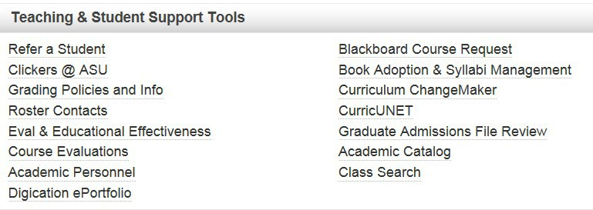

Please Note: At the start of each semester, email your syllabi to [SHPRSFrontDesk@asu.edu***.***](mailto:SHPRSFrontDesk@asu.edu)

Testing Services**:** Please see [Classroom Exam Scanning](https://uoeee.asu.edu/classroom-exam-scanning) for instructions on how to submit classroom exams to University Office of Evaluation and Educational Effectiveness for scanning. Please note: students should provide their own Scantrons.

Textbook/Desk Copy Orders**:** Faculty are responsible for submitting textbook orders and can do so thru MyASU, Teaching and Student Support Tools—same link used for posting syllabi.



Faculty are also responsible for obtaining desk copies when needed. Publishers often require that requests for desk copies be submitted in writing on institutional letterhead. If so, [SHPRS Desk Copy Request Form](https://shprs.asu.edu/sites/default/files/desk_copy_request_form.pdf) can be used.

## GRADUATE PROGRAMS

The [SHPRS Graduate Programs site](https://sites.google.com/asu.edu/shprsgrad) is a comprehensive collection of policies and resources for graduate students in the School of Historical, Philosophical, and Religious Studies at ASU. Visit the site to:

* View information for new and current students, including funding resources and forms.
* View program-specific policies and procedures.

Wellness Resources

[Wellness resources](https://spgs.asu.edu/sites/default/files/wellness_resources_flyer_final.pdf) are available for graduate students!

Graduate Coordinators

Mark Barrios, Graduate Program Student Services Support Coordinator - MA & PhD Tempe Programs: 480-727-7114, [Mark.Barrios@asu.edu](mailto:Mark.Barrios@asu.edu)

Roxanne Shand, Academic Success Coordinator - Online MA History Program:

480-965-5837, [Roxanne.Shand@asu.edu](mailto:Roxanne.Shand@asu.edu)

Kathy O’Malley, Academic Success Specialist - Online World War II Studies, MA:

480-727-2179, [Kathy.OMalley@asu.edu](mailto:Kathy.OMalley@asu.edu)

## UNDERGRADUATE ADVISING

Student services/undergraduate advising staff are located on the third floor, Coor 3307. The advising office telephone number is 480-965-8364. Email: [SHPRSadvising@asu.edu](mailto:SHPRSadvising@asu.edu)

***PLEASE NOTE: Extensions for the advisors are for internal office use only, and should not be released to students or parents.***

|  |  |  |
| --- | --- | --- |
| **Advisor** | **Area** | **Extension** |
| **Manisha Master** | All students | 5-2538 |
| **Michael Currey** | All students | 5-8932 |
| **Amy Kaiman** | All students | 7-3798 |
| **Carole Gallucci** | All students | 5-7183 |
| **Krista Kilian** | All students | 7-0689 |
| **Kristin Farnsworth** | All students | 7-0287 |

# Appendix 1: Business Meal Reimbursement Form

<https://shprs.asu.edu/sites/default/files/business_meals_form_shprs.pdf>

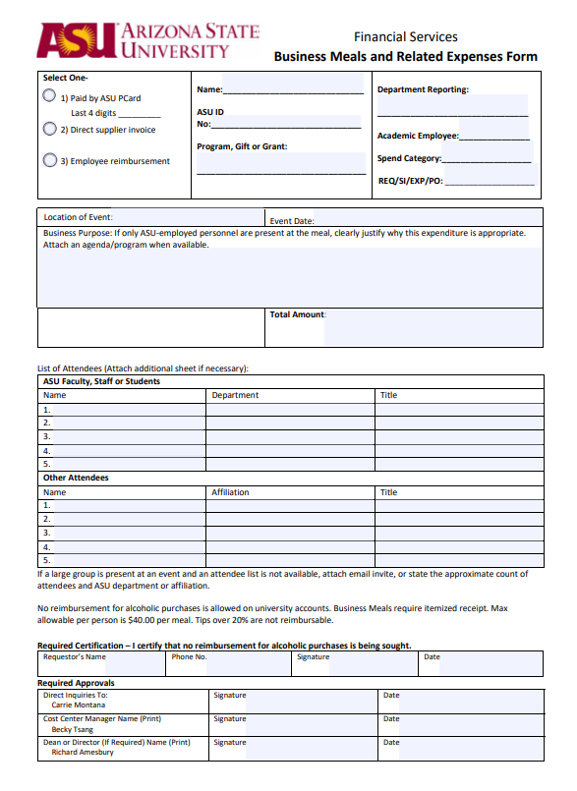

# Appendix 2: SHPRS Purchase/Reimbursement Request

<https://shprs.asu.edu/sites/default/files/purchase_request_form_shprs.pdf>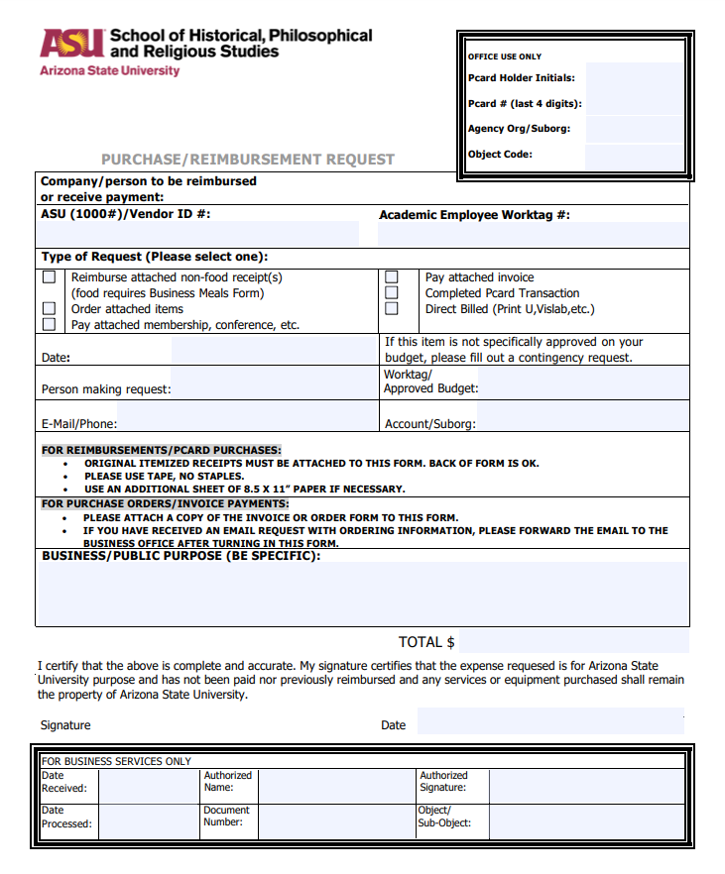

# Appendix 3: Faculty Event Checklist

Let's make it a successful event! This is a resource guide that will help the process go smoothly. Faculty members serving as hosts and/or coordinating a disciplinary event are responsible for planning the event and should complete the following.

|  |  |  |  |  |
| --- | --- | --- | --- | --- |
| **PLANNING** | |  | **EQUIPMENT** | |
| Event Name: | |  | Will you need any equipment for your event? | |
| Type of Event: | |  | Projectors are installed in some SHPRS conference rooms. Portable projectors are also available. | |
| Individual(s) Coordinating Event: |  |  | Laptops are available to checkout, to request email [SHPRSFrontDesk@asu.edu](mailto:SHPRSFrontDesk@asu.edu) | |
| Extra chairs, tables, misc. must be ordered, contact [Rachel Bunning](mailto:rebunnin@mainex1.asu.edu) for more information. | |
|  |  |  |  | |
| Date of Event: | |  | **VISITORS** | |
| Make sure you have consulted both the [university calendar](https://students.asu.edu/academic-calendar) and the [SHPRS calendar](https://shprs.asu.edu/faculty-and-staff-resources) to determine if the date is available and does not conflict with other events within SHPRS. Also consult the [religious calendar](https://eoss.asu.edu/cora/holidays) to ensure that the event does not coincide with a major religious holiday. | |  | Do you need to pay or reimburse a visitor? | |
| Honorarium | Host is to complete the [honorarium request form](https://clas-forms.asu.edu/shprs/request-honorarium). Please see Rob Cochran if you have any questions on how to complete the form. Guest completed forms should be submitted to SHPRS staff for processing. **Forms should be completed and submitted to SHPRS staff at least a month before visit to allow for timely processing.** |
| Airfare up front | Sponsoring/host faculty obtains guest's preferred itinerary, name as it appears on government issued ID to be presented at check-in, and date of birth. Submit all information to SHPRS staff for ticket purchase. |
| StartTime: | |  |  |
| End Time: | |  |  |
| Number of people attending: |  |  |  |
| Location of event: | |  | Reimbursement | OR, guest can purchase own airfare and be reimbursed. If guest receiving honorarium and airfare reimbursement, both payments made at the same  time, on one form (Department  Professional Services Order Form) |
| To reserve a SHPRS conference room, contact [SHPRSFrontDesk@asu.edu](mailto:SHPRSFrontDesk@asu.edu). If you would like a non-SHPRS COOR conference room contact [Rachel Bunning](mailto:rebunnin@mainex1.asu.edu) for options (i.e. The Memorial Union, a classroom, Old Main, The Secret Garden, etc.). | |  |  |
|  | |  |  |
| **BUDGET** | |  |  |  |
| If you have been allotted funds you are responsible for not exceeding your allotment. | |  | **FOOD** | |
| For MU catering you can view the menu and email ASUCatering@gmail.com or call 480-96-6508 to start a catering contract. | |
| Keep track of your expenses and keep all itemized receipts. | |  |
| Useful forms: | [Purchase Request Form](https://shprs.asu.edu/sites/default/files/purchase_request_form_shprs.pdf)  [Business Meal Form](https://shprs.asu.edu/sites/default/files/business_meals_form_shprs.pdf) |  |
| For external vendors please fill out the [purchase request form](https://shprs.asu.edu/sites/default/files/purchase_request_form_shprs.pdf). *3 week processing. | |
| **MARKETING** | |  |
| Consider these marketing sources: | |  |  | |
| Flyer | |  |  | |
| Social media post | |  |  |  |
| Newsletter mention | |  |  |  |
| Email invite | |  |  |  |
| ASU Events posting/Facebook Event posting | |  |  |  |
| TV monitors | |  |  |  |

# 

# Appendix 4: Desk Copy Request Form

<https://shprs.asu.edu/sites/default/files/desk_copy_request_form.pdf>

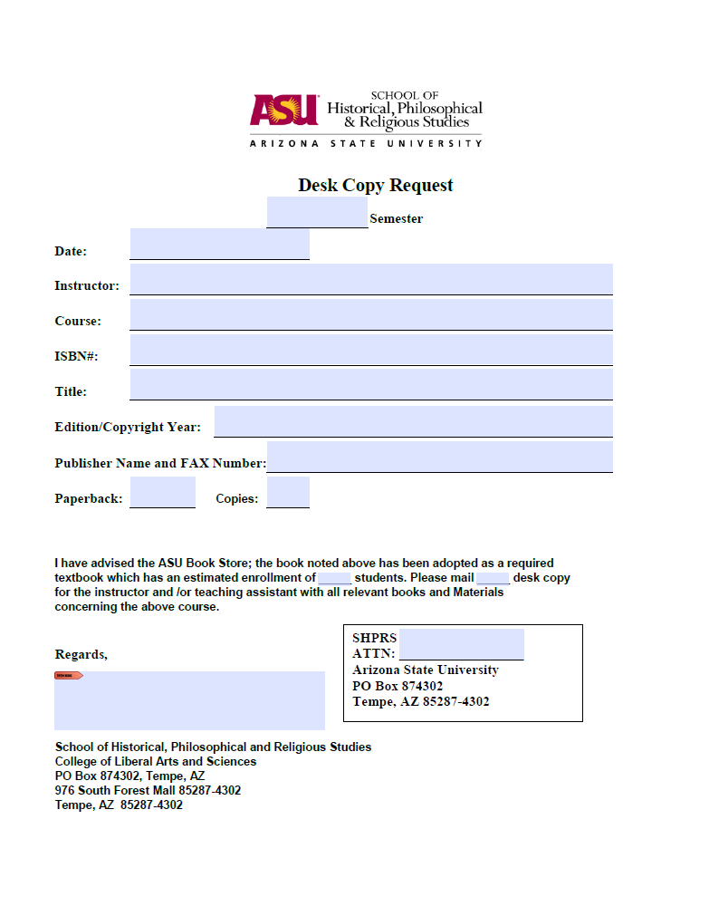

# Appendix 5: Personal Time with Business Travel

**Personal Time with Business Travel:**

**﻿ASU Travel Policy Standard 12: Personal Component of Official ASU Travel**

For trips that contain a personal travel component, ASU will reimburse the traveler for only those expenses that would have been incurred had no personal travel component existed. The traveler should maintain documentation to support that the personal travel component did not add any incremental cost.

Examples of additional costs that may be incurred by the traveler because there is a personal component and that will not be paid by ASU are:

Car Rental

If renting a car for business travel faculty and staff must use an approved [vehicle rental contract](https://cfo.asu.edu/sunmart) and complete the [Authorized Driver Program](https://cfo.asu.edu/authorized-driver-program).

* double occupancy versus single occupancy lodging rates
* per passenger charges for taxis or airport shuttles
* additional car rental costs due to a larger vehicle need
* airfare increases because of a different travel day
* airfare increases for indirect routes
* excess baggage or overweight baggage due to additional travelers

and

* choice of lodging location for the convenience of the personal portion of the trip, as opposed to the convenience of the business purpose

Please note that university insurance coverage does not apply to a vehicle when used outside the scope and course of employment, such as during the personal portion of a trip taken in conjunction with authorized university travel. If insurance is needed for the personal portion of the trip, the traveler is solely responsible for the cost.

**HOW TO ENTER PERSONAL TRAVEL IN MY ASU TRIP/CONCUR?**

On the request header of your trip request in My ASU Trip, only list your business trip dates, with the personal days listed in the comment box and ‘does the trip contain personal travel’ field marked yes.

 On your flight segment, enter the actual business and personal travel dates.

**Cost Comparison Requirements:**

**WHEN IS A COST COMPARISON REQUIRED?**

* When combining personal and business travel:
  + A cost comparison is necessary if the stay at the business location is extended longer than 1 day either prior to or after the dates of the business mission. Generally travel status begins the day prior to business and ends the day after end of business.
  + A cost comparison is required when the airfare includes overnight stays at destinations (excepting normal connecting airports) other than the business destination(s). The traveler must provide a cost comparison showing lowest logical airfare for the direct route to and from the business location for the days of business.
  + A combination personal and business trip does benefit the traveler to some extent, therefore, travelers should exercise special care not to seek reimbursement for expenses that could be construed as personal i.e. additional lodging days beyond the business dates and driving instead of flying, the mileage amount greater then what it would cost to fly to destination will not be reimbursed.
* When leaving from or returning to a location other than 'Duty Post' or place of business:
  + Travel expense reimbursement is limited to the lesser of expenses incurred departing from or returning to the "duty post" or place of business. The duty post is defined as the location of the permanent office.
  + If two adjoining trips are made for University business with no personal travel included, a cost comparison is not required even though the traveler is departing from a location other than the official station to go to the second business location. Make a comment in the trip header noting that there will be no personal travel between trips.

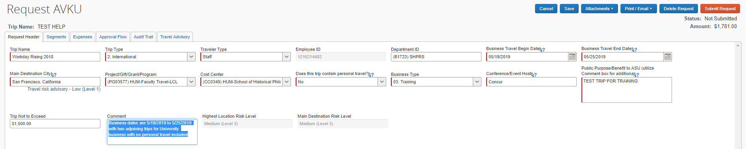

* When Using A Train to Travel in a Foreign Country:
  + A foreign train, bus or other service carrier may be used in lieu of, or as a supplement to air travel at the lowest rate by the transportation facility used.
  + If such travel could have been performed by air, the allowance should not exceed that of the lowest logical coach air accommodations.
* When airfare purchased is a higher class than allowed by University travel guidelines.
* When you drive instead of fly, your car mileage is limited to the cost of what it would be to fly to your destination. Calculate the maximum miles that can be claimed by dividing the allowed airfare amount by .445. Attach the airfare quote to the car mileage expense as a backup for the amount being claimed.

**﻿**

**WHAT DOCUMENTATION QUALIFIES AS A QUOTE/COST COMPARISON?**

1. A cost estimate from an airline that does not include personal dates or destinations:
   1. Airfare quote obtained prior to the trip from Concur - *see example below
      1. **Best Practice: Comparison should be obtained at the same time the trip is arranged**.
   2. Based on:
      1. The business destination(s) for the dates and times of business
      2. Include the day before business begins and day after business ends as travel days
   3. Attach the comparison documentation to expense report or travel request
2. A copy of a co-worker's airfare itinerary/receipt (economy class) that attended the same business event with no personal time or other travel destinations involved.

**WHEN SHOULD A COMPARISON BE OBTAINED?**

Comparisons should be obtained prior to the trip.  **Best Practice: At the same time the trip is planned/arranged**.

**EXAMPLE COST COMARISON**

